After building course sections, you can elect to cluster course sections. Course section clusters can be used to indicate that students must take multiple sections of one course or multiple sections of different courses during the same term.
For example, students who register for the lecture section of a course must also register for a discussion or lab section of the same course.
Use this reference to create a course section cluster.

Table of Contents:
CREATE COURSE SECTION CLUSTER 1
CUSTOMIZE COURSE SECTION CLUSTER 2
One-to-One 3
One-to-Multiple 3
Multiple-to-Multiple 3
EDIT COURSE SECTION CLUSTER 4

CREATE COURSE SECTION CLUSTER
- In the search bar, locate the Maintain Course Section Clusters task.

- In the Maintain Course Section Clusters window, locate the Academic Period field and select the academic period corresponding to the intended cluster.
Locate the Courses to Cluster field and select all targeted courses.
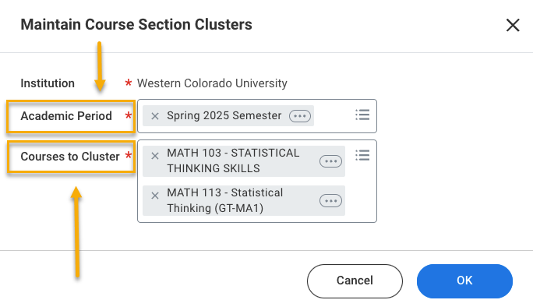
- Click “OK”.

- A table with the selected course will appear.

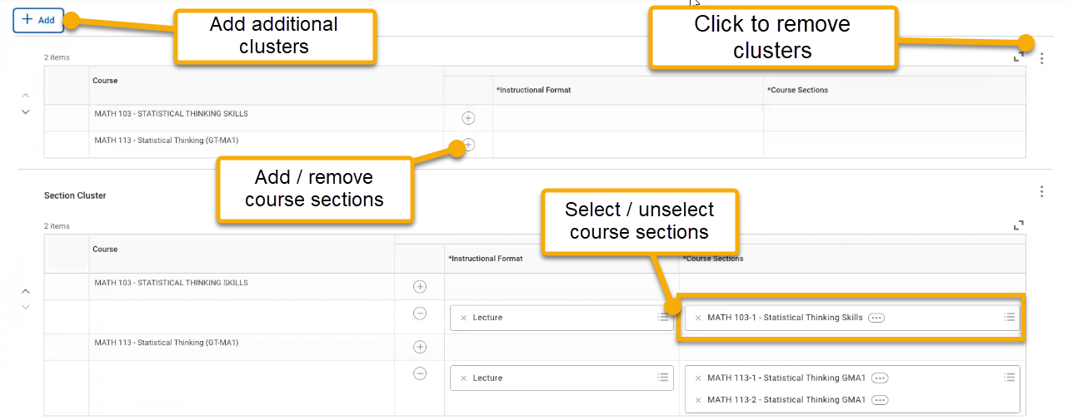

- To add or remove course sections, click the “+” or “-“ sign.

- To select/unselect course sections to include in the cluster, click the Course Sections field.

- When finished, click “OK”.

CUSTOMIZE COURSE SECTION CLUSTER
Course section clusters can be configured to reflect a variety of registration requirements.

One-to-One
This configuration attaches one course section to another course section. This means if a student selects the indicated section of the first course, they must select the indicated section of the second course.
In this example, the student registering for BIOL 140-01 (Lecture) must also register for BIOL 141-L1 (Lab).
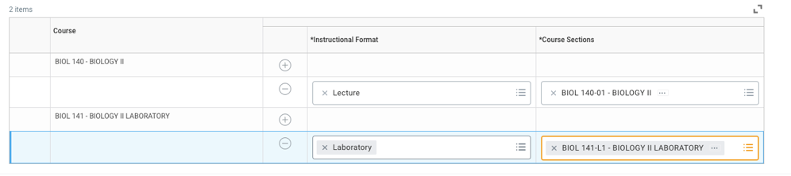

One-to-Multiple
This configuration attaches the course section of the first course to two or more course sections of the second course. This means if a student selects the indicated section of the first course, they must select one of the sections from the second course.
In this example, the student registering for MATH 103-1 (Lecture) must also select and register for either MATH 113-1 or MATH 113-2.
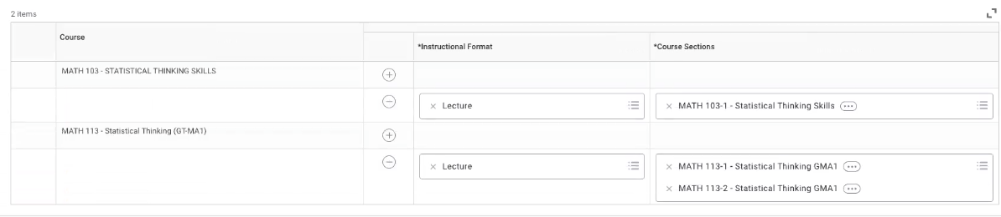

Multiple-to-Multiple
This configuration attaches two or more course sections to a group of two or more other course sections. This means if a student selects any of the sections from the first course, they must select one of the sections from the second course.
In this example, a student registering for one of the listed ANSO 103 course sections must select and register for one of the listed ANSO 105 course sections.
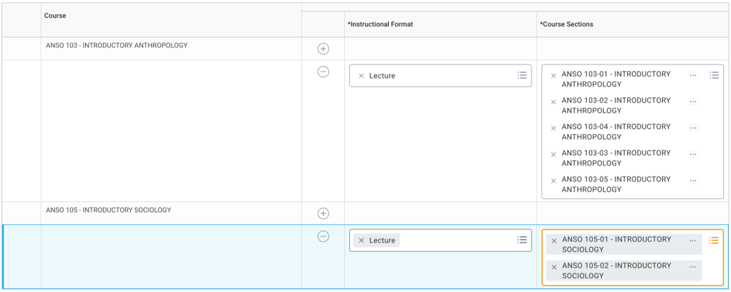

EDIT COURSE SECTION CLUSTER
- Using the search bar, locate the Find Course Section Clusters task.

- In the Find Course Section Clusters task window, locate the Academic Period field and input the targeted academic period.

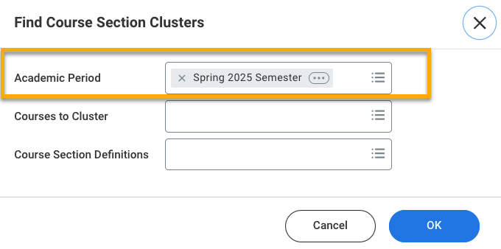

- Click “OK”.

- A table displaying the course section clusters associated with the targeted academic period will appear. Click the related actions icon to view details or edit.
